Decom SfB

Refer to Network Map, SFB 2015 OnPrem Tab for additional details on decom work.

Also consider firewall meraki/Azure (rules removed as per new CheckPoint Firewall deployment project)

# Decom onprem SfB

As per [this](https://learn.microsoft.com/en-us/answers/questions/175452/skype-for-business-server-2015-completely-uninstal.html) and [this](https://learn.microsoft.com/en-us/archive/blogs/canitpro/step-by-step-uninstalling-a-microsoft-lync-server-2013)

Check remaining SfB users

All users with number are no longer required.

Emailed list for verification to Jimmy.

## Disable SfB on remaining user as per list

27/10

PS C:\Users\a_stephenb> Get-CsUser -Filter { HostingProvider -eq "SRV:"} | ft #| Export-Csv -Path "c:\backup\SfbRemainingUsers.csv"

SamAccountName UserPrincipalName FirstName LastName WindowsEmailAddress Sid LineServerURI OriginatorSid AudioVideoDisabled IPPBXSoftPhoneR

outingEnabled

-------------- ----------------- --------- -------- ------------------- --- ------------- ------------- ------------------ ---------------

adam.l adam.l@scenicrim.qld.gov.au Adam Long adam.l@scenicrim.qld.gov.au S-1-5-21-720006934-1082272784-1543857936-25679 False False

Adrian.W Adrian.W@scenicrim.qld.gov.au Adrian Williams Adrian.W@scenicrim.qld.gov.au S-1-5-21-720006934-1082272784-1543857936-36779 False False

Amy.F Amy.F@scenicrim.qld.gov.au Amy Fraser Amy.F@scenicrim.qld.gov.au S-1-5-21-720006934-1082272784-1543857936-36728 False False

Andrea.L Andrea.L@scenicrim.qld.gov.au Andrea Lee Andrea.L@scenicrim.qld.gov.au S-1-5-21-720006934-1082272784-1543857936-136869 False False

auditor.1 auditor.1@scenicrim.qld.gov.au Auditor 1 auditor.1@scenicrim.qld.gov.au S-1-5-21-720006934-1082272784-1543857936-39561 False False

Auditor.2 Auditor.2@scenicrim.qld.gov.au Auditor 2 Auditor.2@scenicrim.qld.gov.au S-1-5-21-720006934-1082272784-1543857936-39562 False False

bdsl5286 bdsl5286@ad.bsc.qld.gov.au Beaudesert Soil Lab 5286 bdsl5286@scenicrim.qld.gov.au S-1-5-21-720006934-1082272784-1543857936-14077 False False

Caitlin.B Caitlin.B@scenicrim.qld.gov.au Caitlin Barr Caitlin.B@scenicrim.qld.gov.au S-1-5-21-720006934-1082272784-1543857936-136596 False False

etnait_support etnait_support@scenicrim.qld.gov.au EtnaIT_Support etnait_support@scenicrim.qld.gov.au S-1-5-21-720006934-1082272784-1543857936-13266 False False

geomant_support geomant_support@scenicrim.qld.gov.au Geomant_Support geomant_support@scenicrim.qld.gov.au S-1-5-21-720006934-1082272784-1543857936-25689 False False

Grant.M Grant.M@scenicrim.qld.gov.au Grant Mayne Grant.M@scenicrim.qld.gov.au S-1-5-21-720006934-1082272784-1543857936-37008 False False

insync.onprem insync.onprem@scenicrim.qld.gov.au insync onprem insync.onprem@scenicrim.qld.gov.au S-1-5-21-720006934-1082272784-1543857936-36735 False False

jeff.d jeff.d@scenicrim.qld.gov.au Jeff Day jeff.d@scenicrim.qld.gov.au S-1-5-21-720006934-1082272784-1543857936-10497 False False

Joanne.R Joanne.R@scenicrim.qld.gov.au Joanne Regan Joanne.R@scenicrim.qld.gov.au S-1-5-21-720006934-1082272784-1543857936-37003 False False

joshua.b joshua.b@scenicrim.qld.gov.au Joshua Baker joshua.b@scenicrim.qld.gov.au S-1-5-21-720006934-1082272784-1543857936-12485 False False

Kartik.V Kartik.V@scenicrim.qld.gov.au Kartik Venkatraman Kartik.V@scenicrim.qld.gov.au S-1-5-21-720006934-1082272784-1543857936-36904 False False

ldccadmin1 ldccadmin1@scenicrim.qld.gov.au LDCC Admin 1 ldccadmin1@scenicrim.qld.gov.au S-1-5-21-720006934-1082272784-1543857936-39642 False False

ldcclogistics1 ldcclogistics1@scenicrim.qld.gov.au LDCC Logistics 1 ldcclogistics1@scenicrim.qld.gov.au S-1-5-21-720006934-1082272784-1543857936-39638 False False

ldccoperations1 ldccoperations1@scenicrim.qld.gov.au LDCC Operations 1 ldccoperations1@scenicrim.qld.gov.au S-1-5-21-720006934-1082272784-1543857936-39634 False False

ldccplanning2 ldccplanning2@scenicrim.qld.gov.au LDCC Planning 2 ldccplanning2@scenicrim.qld.gov.au S-1-5-21-720006934-1082272784-1543857936-39622 False False

Leo.S Leo.S@scenicrim.qld.gov.au Leo Stewart Leo.S@scenicrim.qld.gov.au S-1-5-21-720006934-1082272784-1543857936-37004 False False

Lucy.S Lucy.S@scenicrim.qld.gov.au Lucy Schluter Lucy.S@scenicrim.qld.gov.au S-1-5-21-720006934-1082272784-1543857936-54515 False False

Malcolm.S Malcolm.S@scenicrim.qld.gov.au Malcolm Savage Malcolm.S@scenicrim.qld.gov.au S-1-5-21-720006934-1082272784-1543857936-136852 False False

Manager.Planning Manager.Planning@ad.bsc.qld.gov.au Manager.Planning@scenicrim.qld.gov.au S-1-5-21-720006934-1082272784-1543857936-39797 False False

megan.s megan.s@scenicrim.qld.gov.au Megan Stokes megan.s@scenicrim.qld.gov.au S-1-5-21-720006934-1082272784-1543857936-1155 False False

MRChambersBeaud MRChambersBeaudesert@scenicrim.qld.gov.au MRChambersBeaudesert@scenicrim.qld.gov.au S-1-5-21-720006934-1082272784-1543857936-10374 False False

Paula.H Paula.H@scenicrim.qld.gov.au Paula Hackney Paula.H@scenicrim.qld.gov.au S-1-5-21-720006934-1082272784-1543857936-37000 False False

Sarah.K Sarah.K@scenicrim.qld.gov.au Sarah Kirley Sarah.K@scenicrim.qld.gov.au S-1-5-21-720006934-1082272784-1543857936-136820 False False

SESEOC1 SESEOC1@scenicrim.qld.gov.au SESEOC1 SESEOC1@scenicrim.qld.gov.au S-1-5-21-720006934-1082272784-1543857936-12513 False False

SESEOC3 SESEOC3@scenicrim.qld.gov.au SESEOC3 SESEOC3@scenicrim.qld.gov.au S-1-5-21-720006934-1082272784-1543857936-13866 False False

SESEOC4 SESEOC4@scenicrim.qld.gov.au SESEOC4 SESEOC4@scenicrim.qld.gov.au S-1-5-21-720006934-1082272784-1543857936-13016 False False

SESEOC5 SESEOC5@scenicrim.qld.gov.au SESEOC5 SESEOC5@scenicrim.qld.gov.au S-1-5-21-720006934-1082272784-1543857936-13294 False False

Sharon.P Sharon.P@scenicrim.qld.gov.au Sharon Phillips Sharon.P@scenicrim.qld.gov.au S-1-5-21-720006934-1082272784-1543857936-37011 False False

srrcaudio srrcaudio@scenicrim.qld.gov.au srrcaudio@scenicrim.qld.gov.au S-1-5-21-720006934-1082272784-1543857936-52048 False False

StaffTest2 StaffTest2@scenicrim.qld.gov.au Staff Test2 stafftest2@scenicrim.qld.gov.au S-1-5-21-720006934-1082272784-1543857936-25718 False False

Supipi.P Supipi.P@scenicrim.qld.gov.au Supipi Peiris Supipi.P@scenicrim.qld.gov.au S-1-5-21-720006934-1082272784-1543857936-36999 False False

Training1 Training1@scenicrim.qld.gov.au Training User 1 Training1@scenicrim.qld.gov.au S-1-5-21-720006934-1082272784-1543857936-10423 False False

Training10 Training10@scenicrim.qld.gov.au Training User 10 Training10@scenicrim.qld.gov.au S-1-5-21-720006934-1082272784-1543857936-12158 False False

Training2 Training2@scenicrim.qld.gov.au Training User 2 Training2@scenicrim.qld.gov.au S-1-5-21-720006934-1082272784-1543857936-12120 False False

Training3 Training3@scenicrim.qld.gov.au Training User 3 Training3@scenicrim.qld.gov.au S-1-5-21-720006934-1082272784-1543857936-12121 False False

Training4 training4@scenicrim.qld.gov.au Training User 4 Training4@scenicrim.qld.gov.au S-1-5-21-720006934-1082272784-1543857936-12152 False False

Training5 Training5@scenicrim.qld.gov.au Training User 5 Training5@scenicrim.qld.gov.au S-1-5-21-720006934-1082272784-1543857936-12153 False False

Training6 Training6@scenicrim.qld.gov.au Training User 6 Training6@scenicrim.qld.gov.au S-1-5-21-720006934-1082272784-1543857936-12154 False False

Training7 Training7@scenicrim.qld.gov.au Training User 7 Training7@scenicrim.qld.gov.au S-1-5-21-720006934-1082272784-1543857936-12155 False False

Training8 Training8@scenicrim.qld.gov.au Training User 8 Training8@scenicrim.qld.gov.au S-1-5-21-720006934-1082272784-1543857936-12156 False False

Training9 Training9@scenicrim.qld.gov.au Training User 9 Training9@scenicrim.qld.gov.au S-1-5-21-720006934-1082272784-1543857936-12157 False False

Vannessa.M Vannessa.M@scenicrim.qld.gov.au Vannessa Moore Vannessa.M@scenicrim.qld.gov.au S-1-5-21-720006934-1082272784-1543857936-40073 False False

vasu.p vasu.p@scenicrim.qld.gov.au Vasu Pardeshi vasu.p@scenicrim.qld.gov.au S-1-5-21-720006934-1082272784-1543857936-14573 False False

PS C:\Users\a_stephenb> Get-CsUser -Filter { HostingProvider -eq "SRV:"} | Disable-CsUser

PS C:\Users\a_stephenb> Get-CsUser -Filter { HostingProvider -eq "SRV:"} | ft

PS C:\Users\a_stephenb> Get-CsHostingProvider|Set-CsHostingProvider -Enabled $false

PS C:\Users\a_stephenb> Get-CsHostingProvider

Identity : Exchange Online

Name : Exchange Online

ProxyFqdn : exap.um.outlook.com

VerificationLevel : UseSourceVerification

Enabled : False

EnabledSharedAddressSpace : True

HostsOCSUsers : False

IsLocal : False

AutodiscoverUrl :

Identity : LyncOnlineResources

Name : LyncOnlineResources

ProxyFqdn : sipfed.resources.lync.com

VerificationLevel : AlwaysVerifiable

Enabled : False

EnabledSharedAddressSpace : False

HostsOCSUsers : False

IsLocal : False

AutodiscoverUrl :

Identity : Office365

Name : Office365

ProxyFqdn : sipfed.online.lync.com

VerificationLevel : UseSourceVerification

Enabled : False

EnabledSharedAddressSpace : True

HostsOCSUsers : True

IsLocal : False

AutodiscoverUrl : https://webdir.online.lync.com/Autodiscover/AutodiscoverService.svc/root

Run ADSync on AZ-AADCV2

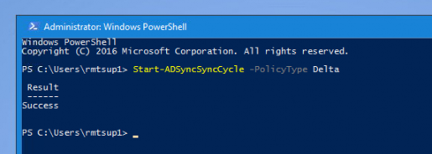

## Remove external DNS record

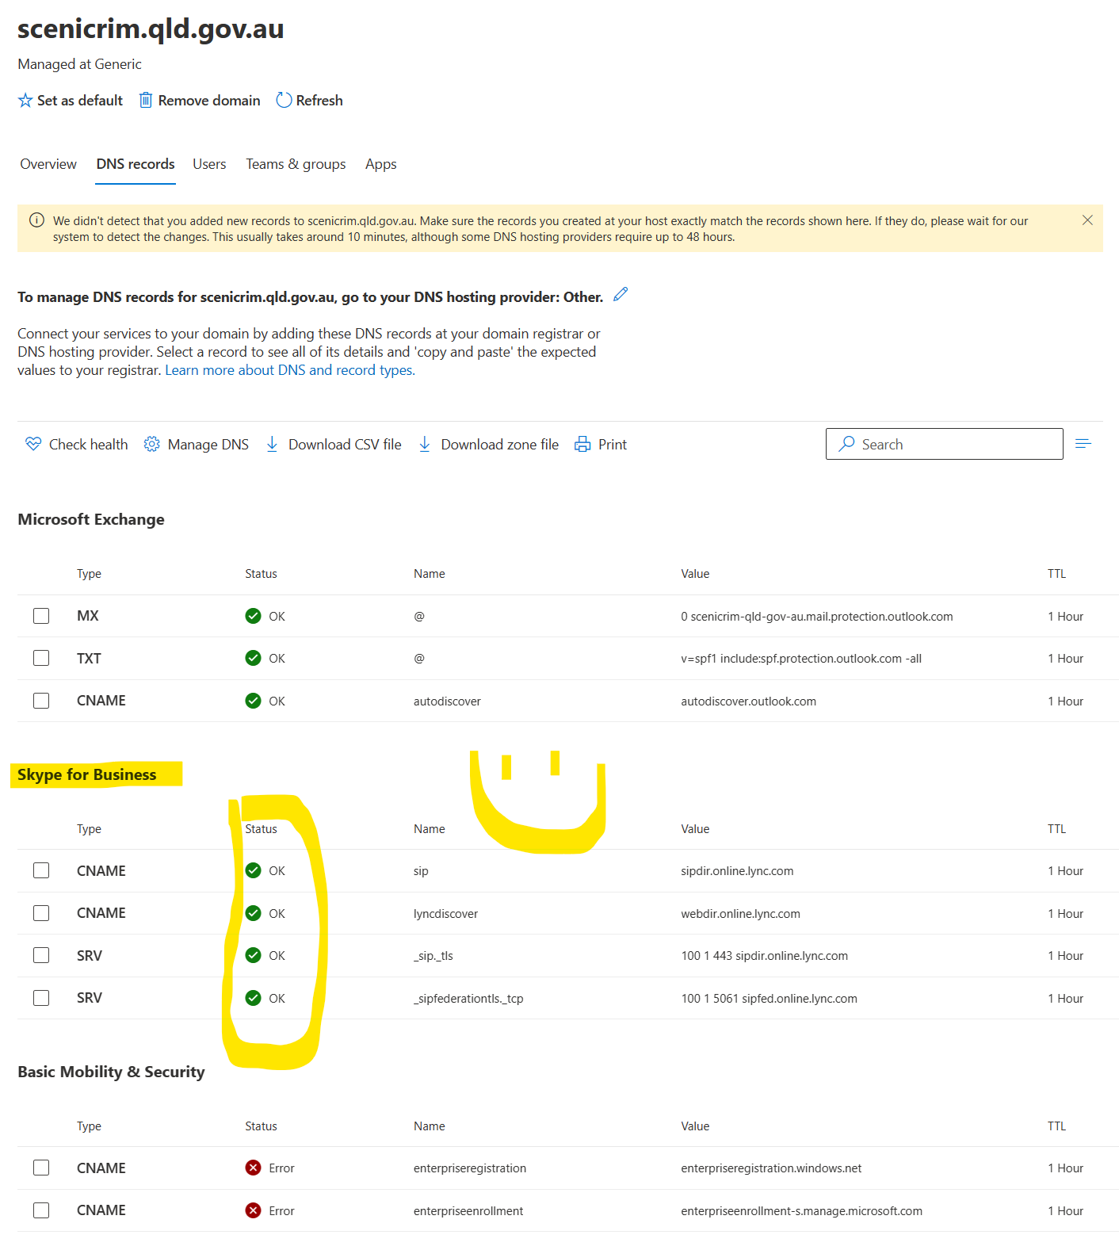

## Set Teams only mode

Done

PS C:\Users\StephenBell> Grant-CsTeamsUpgradePolicy -PolicyName UpgradeToTeams -Global -verbose

VERBOSE: EnabledForFlight: True, AutoRestCommandInfo: True

PS C:\Users\StephenBell> Get-CsTeamsUpgradePolicy -identity Global -verbose

VERBOSE: EnabledForFlight: True, AutoRestCommandInfo: True

Identity : Global

Description : Use Teams Only

Mode : TeamsOnly

NotifySfbUsers : False

Action : Upgrade

Verify in portal

Disable shared sip address space in Microsoft 365 organization

PS C:\Users\StephenBell> Set-CsTenantFederationConfiguration -SharedSipAddressSpace $false

Disable communication between the on-premises environment and Microsoft 365, run the following command from an on-premises PowerShell window:

PS C:\Users\a_stephenb> Get-CsHostingProvider|Set-CsHostingProvider -Enabled $false

PS C:\Users\a_stephenb> Get-CsHostingProvider

Identity : Exchange Online

Name : Exchange Online

ProxyFqdn : exap.um.outlook.com

VerificationLevel : UseSourceVerification

Enabled : False

EnabledSharedAddressSpace : True

HostsOCSUsers : False

IsLocal : False

AutodiscoverUrl :

Identity : LyncOnlineResources

Name : LyncOnlineResources

ProxyFqdn : sipfed.resources.lync.com

VerificationLevel : AlwaysVerifiable

Enabled : False

EnabledSharedAddressSpace : False

HostsOCSUsers : False

IsLocal : False

AutodiscoverUrl :

Identity : Office365

Name : Office365

ProxyFqdn : sipfed.online.lync.com

VerificationLevel : UseSourceVerification

Enabled : False

EnabledSharedAddressSpace : True

HostsOCSUsers : True

IsLocal : False

AutodiscoverUrl : https://webdir.online.lync.com/Autodiscover/AutodiscoverService.svc/root

## Test calls

RMT Test account

Login Ok – web app

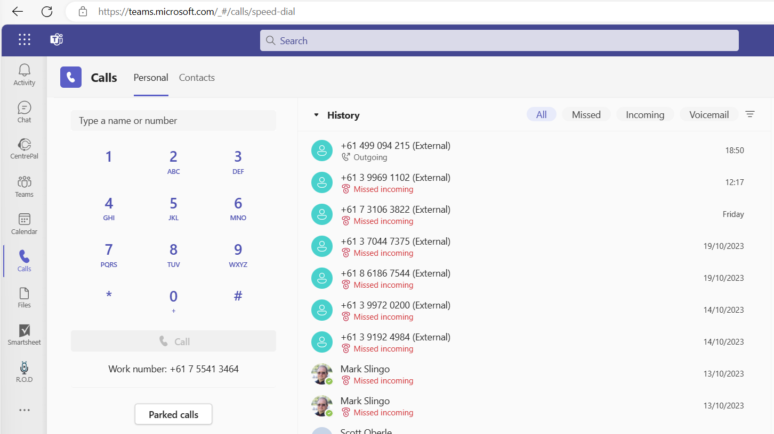

Out to mobile ok

Inbound ok

Internal to internal

ok

RMT Teams to TRC Teams

**Call Main**

Calling **07 5540 5111** hits Centrepal IVR. – OK

# Internal DNS

172.19.20.73 = SFBFE01

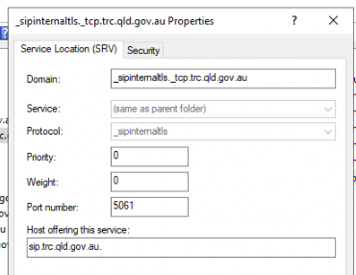

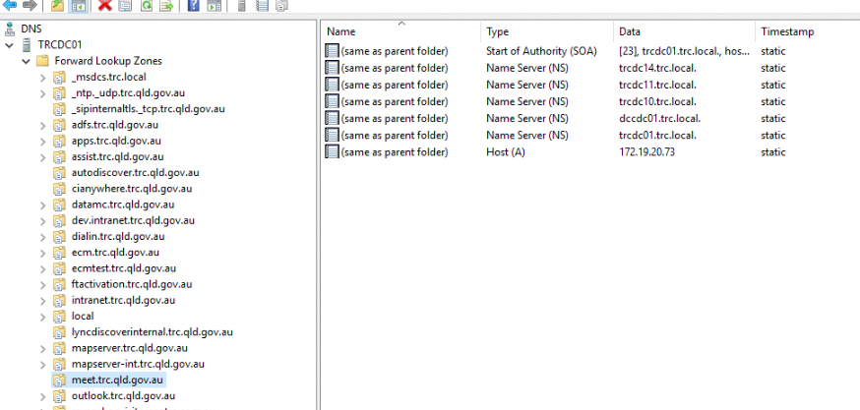

Pause the following fwd lookup zones 5/12 @ 17:05













# Additional Steps

All servers that are part of infrastructure

SFBFE01 (decom)

SFBED01 (decom) Complete 19/1

SFBWA01 (shutdown) No specific decom required.

EXT2-RP-02 (shutdown, may be required for other services? (named wrong on network map. IP match)

SFBSBA01 (shutdown – Part of SFBSBC01) Down during removal of SBC

Enghouse Servers – Shutdown after Call recording exported – Export done 13/1/23

EHCC01

EHQMS01

SHUTDOWN ALL SERVERS FOR A DAY.

*************

DONT start decom work until approved by Jimmy/Amanda. Enghouse call recording dependency

*************

Approved by Jimmy 18/1 - Ticket 267283

9 Jan 23

Enghouse call recordings copied to TRC-FILE02 E:\Enghouse Call Recordings Archive

10 Jan - Start servers and prepare for decom as per steps below

SFBFE01

SFBED01

SFBWA01

EXT2-RP-01

SFBSBA01

EHCC01

EHQMS01

# Review onsite deployment components.

## Prepare to remove the Skype for Business deployment

After you move all required user accounts to the cloud, there may still be some remaining on-premises objects such as contacts and applications that you will need clean up.

Use the steps below to clean these objects, and make sure you're a member of both the Local Administrator group and the RTCUniversalServerAdmins group. Note that ExUmContacts and PersistantChatEndPoints aren't available in Skype for Business Server 2019. If you have Skype for Business Server 2019, the corresponding cmdlets in the steps below should be omitted.

1. To check if there are any contacts or applications associated with the Skype for Business Server on-premises deployment, run the following Skype for Business Server PowerShell cmdlets.

PS C:\Users\a_stephenb> Get-CsCommonAreaPhone

Identity : CN={c1b72c61-8334-4395-b08f-fdcf934df734},OU=Scenic Rim Regional Council Users,DC=ad,DC=bsc,DC=qld,DC=gov,DC=au

RegistrarPool : ds-sfb-01.ad.bsc.qld.gov.au

Enabled : True

SipAddress : sip:9baef685-2d6c-4ab6-b813-866dcac561ad@scenicrim.qld.gov.au

ClientPolicy :

PinPolicy :

VoicePolicy :

VoiceRoutingPolicy :

MobilityPolicy :

PersistentChatPolicy :

ConferencingPolicy :

LineURI :

DisplayNumber :

DisplayName :

Description :

ExUmEnabled : False

Identity : CN=BMS Desk 5058,OU=Lync,OU=Scenic Rim Regional Council Users,DC=ad,DC=bsc,DC=qld,DC=gov,DC=au

RegistrarPool : ds-sfb-01.ad.bsc.qld.gov.au

Enabled : True

SipAddress : sip:BBMS5058@scenicrim.qld.gov.au

ClientPolicy :

PinPolicy :

VoicePolicy :

VoiceRoutingPolicy :

MobilityPolicy :

PersistentChatPolicy :

ConferencingPolicy :

LineURI : tel:+61755405058;ext=5058

DisplayNumber : (07) 5540 5058

DisplayName : BMS Desk 5058

Description : 08/07/14 Level 3 Facilities BMS Desk 5058

ExUmEnabled : False

Identity : CN=Boonah Cultural Centre Common Area Phone,OU=Lync,OU=Scenic Rim Regional Council Users,DC=ad,DC=bsc,DC=qld,DC=gov,DC=au

RegistrarPool : ds-sfb-01.ad.bsc.qld.gov.au

Enabled : True

SipAddress : sip:BCC3070@scenicrim.qld.gov.au

ClientPolicy :

PinPolicy :

VoicePolicy :

VoiceRoutingPolicy :

MobilityPolicy :

PersistentChatPolicy :

ConferencingPolicy :

LineURI : tel:+61754633070;ext=3070

DisplayNumber : (07) 5463 3070

DisplayName : Boonah Cultural Centre Common Area Phone 3070

Description : Boonah Cultural Centre Common Area phone 3070

ExUmEnabled : False

Identity : CN=Beaudesert Council Chambers 5106,OU=Lync,OU=Scenic Rim Regional Council Users,DC=ad,DC=bsc,DC=qld,DC=gov,DC=au

RegistrarPool : ds-sfb-01.ad.bsc.qld.gov.au

Enabled : True

SipAddress : sip:BCCH5106@scenicrim.qld.gov.au

ClientPolicy :

PinPolicy :

VoicePolicy :

VoiceRoutingPolicy :

MobilityPolicy :

PersistentChatPolicy :

ConferencingPolicy :

LineURI : tel:+61755405106;ext=5106

DisplayNumber : (07) 5540 5106

DisplayName : Beaudesert Council Chambers 5106

Description : 13/06/14 Council Chambers Beaudesert 5106

ExUmEnabled : False

Identity : CN=Beaudesert Cultural Centre Kitchen 5054,OU=Lync,OU=Scenic Rim Regional Council Users,DC=ad,DC=bsc,DC=qld,DC=gov,DC=au

RegistrarPool : ds-sfb-01.ad.bsc.qld.gov.au

Enabled : True

SipAddress : sip:BCK5054@scenicrim.qld.gov.au

ClientPolicy :

PinPolicy :

VoicePolicy :

VoiceRoutingPolicy :

MobilityPolicy :

PersistentChatPolicy :

ConferencingPolicy :

LineURI : tel:+61755405054;ext=5054

DisplayNumber : (07) 5540 5054

DisplayName : Beaudesert CC Kitchen

Description : 06/06/14 Beaudesert Cultural Centre Kitchen 5054

ExUmEnabled : False

Identity : CN=Contact Centre Front Desk 1 5122,OU=Lync,OU=Scenic Rim Regional Council Users,DC=ad,DC=bsc,DC=qld,DC=gov,DC=au

RegistrarPool : ds-sfb-01.ad.bsc.qld.gov.au

Enabled : True

SipAddress : sip:Beaudesert.ContactCentre1@scenicrim.qld.gov.au

ClientPolicy :

PinPolicy :

VoicePolicy :

VoiceRoutingPolicy :

MobilityPolicy :

PersistentChatPolicy :

ConferencingPolicy :

LineURI : tel:+61755405122;ext=5122

DisplayNumber : (07) 5540 5122

DisplayName : Contact Centre Front Desk 1 5122

Description :

ExUmEnabled : False

Identity : CN=Contact Centre Front Desk 2 5222,OU=Lync,OU=Scenic Rim Regional Council Users,DC=ad,DC=bsc,DC=qld,DC=gov,DC=au

RegistrarPool : ds-sfb-01.ad.bsc.qld.gov.au

Enabled : True

SipAddress : sip:Beaudesert.ContactCentre2@scenicrim.qld.gov.au

ClientPolicy :

PinPolicy :

VoicePolicy :

VoiceRoutingPolicy :

MobilityPolicy :

PersistentChatPolicy :

ConferencingPolicy :

LineURI : tel:+61755405222;ext=5222

DisplayNumber : (07) 5540 5222

DisplayName : Contact Centre Front Desk 2 5222

Description :

ExUmEnabled : False

Identity : CN=Level 1 Finance Meeting Room 5178,OU=Lync,OU=Scenic Rim Regional Council Users,DC=ad,DC=bsc,DC=qld,DC=gov,DC=au

RegistrarPool : ds-sfb-01.ad.bsc.qld.gov.au

Enabled : True

SipAddress : sip:BFMR5178@scenicrim.qld.gov.au

ClientPolicy :

PinPolicy :

VoicePolicy :

VoiceRoutingPolicy :

MobilityPolicy :

PersistentChatPolicy :

ConferencingPolicy :

LineURI : tel:+61755405178;ext=5178

DisplayNumber : (07) 5540 5178

DisplayName : Level 1 Finance Meeting Room 5178

Description : Level 1 Finance Meeting Room 5178

ExUmEnabled : False

Identity : CN=Boonah Library Front Desk,OU=Lync,OU=Scenic Rim Regional Council Users,DC=ad,DC=bsc,DC=qld,DC=gov,DC=au

RegistrarPool : ds-sfb-01.ad.bsc.qld.gov.au

Enabled : True

SipAddress : sip:bol3064@scenicrim.qld.gov.au

ClientPolicy :

PinPolicy :

VoicePolicy :

VoiceRoutingPolicy :

MobilityPolicy :

PersistentChatPolicy :

ConferencingPolicy :

LineURI : tel:+61754633064;ext=3064

DisplayNumber : (07) 5463 3064

DisplayName : Boonah Library Front Desk

Description : Boonah Library Front Desk - 54633064

ExUmEnabled : False

Identity : CN=Boonah Mayor 1 3015,OU=Lync,OU=Scenic Rim Regional Council Users,DC=ad,DC=bsc,DC=qld,DC=gov,DC=au

RegistrarPool : ds-sfb-01.ad.bsc.qld.gov.au

Enabled : True

SipAddress : sip:boonah.mayor1@scenicrim.qld.gov.au

ClientPolicy :

PinPolicy :

VoicePolicy :

VoiceRoutingPolicy :

MobilityPolicy :

PersistentChatPolicy :

ConferencingPolicy :

LineURI : tel:+61754633015;ext=3015

DisplayNumber : (07) 5463 3015

DisplayName : Boonah Mayor 1 3015

Description :

ExUmEnabled : False

Identity : CN=Boonah Records 3069,OU=Lync,OU=Scenic Rim Regional Council Users,DC=ad,DC=bsc,DC=qld,DC=gov,DC=au

RegistrarPool : ds-sfb-01.ad.bsc.qld.gov.au

Enabled : True

SipAddress : sip:BRC3069@scenicrim.qld.gov.au

ClientPolicy :

PinPolicy :

VoicePolicy :

VoiceRoutingPolicy :

MobilityPolicy :

PersistentChatPolicy :

ConferencingPolicy :

LineURI : tel:+61754633069;ext=3069

DisplayNumber : (07) 5463 3069

DisplayName : Boonah Records 3069

Description : Boonah Records 3069

ExUmEnabled : False

Identity : CN=Regional Services Meeting Room 2 5375,OU=Lync,OU=Scenic Rim Regional Council Users,DC=ad,DC=bsc,DC=qld,DC=gov,DC=au

RegistrarPool : ds-sfb-01.ad.bsc.qld.gov.au

Enabled : True

SipAddress : sip:BRS5375@scenicrim.qld.gov.au

ClientPolicy :

PinPolicy :

VoicePolicy :

VoiceRoutingPolicy :

MobilityPolicy :

PersistentChatPolicy :

ConferencingPolicy :

LineURI : tel:+61755405375;ext=5375

DisplayNumber : (07) 5540 5375

DisplayName : Regional Services Meeting Room 2 5375

Description : Level 5 Large Regional Services Meeting Room 5375

ExUmEnabled : False

Identity : CN=Beaudesert SES Phone 5919,OU=Lync,OU=Scenic Rim Regional Council Users,DC=ad,DC=bsc,DC=qld,DC=gov,DC=au

RegistrarPool : ds-sfb-01.ad.bsc.qld.gov.au

Enabled : True

SipAddress : sip:BSES5919@scenicrim.qld.gov.au

ClientPolicy :

PinPolicy :

VoicePolicy :

VoiceRoutingPolicy :

MobilityPolicy :

PersistentChatPolicy :

ConferencingPolicy :

LineURI : tel:+61755405919;ext=5919

DisplayNumber : (07) 5540 5919

DisplayName : Beaudesert SES Phone 5919

Description : 12/06/14 Beaudesert SES Command Centre 5919

ExUmEnabled : False

Identity : CN=Beaudesert Works Area 1 5653,OU=Lync,OU=Scenic Rim Regional Council Users,DC=ad,DC=bsc,DC=qld,DC=gov,DC=au

RegistrarPool : ds-sfb-01.ad.bsc.qld.gov.au

Enabled : True

SipAddress : sip:bwa1@scenicrim.qld.gov.au

ClientPolicy :

PinPolicy :

VoicePolicy :

VoiceRoutingPolicy :

MobilityPolicy :

PersistentChatPolicy :

ConferencingPolicy :

LineURI : tel:+6155405653;ext=5653

DisplayNumber : (07) 5540 5653

DisplayName : Beaudesert Works Area 1 5653

Description : Beaudesert Works Area 1 Common Area Phone 5653

ExUmEnabled : False

Identity : CN=Beaudesert Works Area 2 5654,OU=Lync,OU=Scenic Rim Regional Council Users,DC=ad,DC=bsc,DC=qld,DC=gov,DC=au

RegistrarPool : ds-sfb-01.ad.bsc.qld.gov.au

Enabled : True

SipAddress : sip:bwa2@scenicrim.qld.gov.au

ClientPolicy :

PinPolicy :

VoicePolicy :

VoiceRoutingPolicy :

MobilityPolicy :

PersistentChatPolicy :

ConferencingPolicy :

LineURI : tel:+6155405654;ext=5654

DisplayNumber : (07) 5540 5654

DisplayName : Beaudesert Works Area 2 5654

Description : Beaudesert Works Area 2 Common Area Phone 5654

ExUmEnabled : False

Identity : CN=Cultural Centre Mushroom,OU=Lync,OU=Scenic Rim Regional Council Users,DC=ad,DC=bsc,DC=qld,DC=gov,DC=au

RegistrarPool : ds-sfb-01.ad.bsc.qld.gov.au

Enabled : True

SipAddress : sip:ccm5995@scenicrim.qld.gov.au

ClientPolicy :

PinPolicy :

VoicePolicy :

VoiceRoutingPolicy :

MobilityPolicy :

PersistentChatPolicy :

ConferencingPolicy :

LineURI : tel:+61755405995;ext=5995

DisplayNumber : (07) 5540 5995

DisplayName : Cultural Centre Mushroom

Description : Cultural Centre Speaker phone

ExUmEnabled : False

Identity : CN=Councillors Multifunction room kitchen 5325,OU=Lync,OU=Scenic Rim Regional Council Users,DC=ad,DC=bsc,DC=qld,DC=gov,DC=au

RegistrarPool : ds-sfb-01.ad.bsc.qld.gov.au

Enabled : True

SipAddress : sip:CMFK5325@scenicrim.qld.gov.au

ClientPolicy :

PinPolicy :

VoicePolicy :

VoiceRoutingPolicy :

MobilityPolicy :

PersistentChatPolicy :

ConferencingPolicy :

LineURI : tel:+61755405325;ext=5325

DisplayNumber : (07) 5540 5325

DisplayName : Councillors Multifunction room kitchen 5325

Description : 17/06/14 Kitchen for Councillors multifunction room 5325

ExUmEnabled : False

Identity : CN=LDCC/Outside Learning Room 5636,OU=Lync,OU=Scenic Rim Regional Council Users,DC=ad,DC=bsc,DC=qld,DC=gov,DC=au

RegistrarPool : ds-sfb-01.ad.bsc.qld.gov.au

Enabled : True

SipAddress : sip:EOC5636@scenicrim.qld.gov.au

ClientPolicy :

PinPolicy :

VoicePolicy : BEAU-International

VoiceRoutingPolicy :

MobilityPolicy :

PersistentChatPolicy :

ConferencingPolicy :

LineURI : tel:+61755405636

DisplayNumber : (07) 5540 5636

DisplayName : LDCC Administration/Computer Training Room

Description : 04/07/14 EOC Common Area Phone 5636

ExUmEnabled : False

Identity : CN=EOC Common Area Phone 2 5637,OU=Lync,OU=Scenic Rim Regional Council Users,DC=ad,DC=bsc,DC=qld,DC=gov,DC=au

RegistrarPool : ds-sfb-01.ad.bsc.qld.gov.au

Enabled : True

SipAddress : sip:EOC5637@scenicrim.qld.gov.au

ClientPolicy :

PinPolicy :

VoicePolicy :

VoiceRoutingPolicy :

MobilityPolicy :

PersistentChatPolicy :

ConferencingPolicy :

LineURI : tel:+61755405637

DisplayNumber : (07) 5540 5637

DisplayName : LDCC Room Manager/Computer Training Room

Description : Common Area phone for LDCC 5637

ExUmEnabled : False

Identity : CN=Executive 3 Meeting Room 5207,OU=Lync,OU=Scenic Rim Regional Council Users,DC=ad,DC=bsc,DC=qld,DC=gov,DC=au

RegistrarPool : ds-sfb-01.ad.bsc.qld.gov.au

Enabled : True

SipAddress : sip:EXECMR3@scenicrim.qld.gov.au

ClientPolicy :

PinPolicy :

VoicePolicy :

VoiceRoutingPolicy :

MobilityPolicy :

PersistentChatPolicy :

ConferencingPolicy :

LineURI : tel:+61755405207;ext=5207

DisplayNumber : (07) 5540 5207

DisplayName : Executive 3 Meeting Room 5207

Description : 18/06/14 Executive Meeting Room 3 5207

ExUmEnabled : False

Identity : CN=HR Training Room,OU=Lync,OU=Scenic Rim Regional Council Users,DC=ad,DC=bsc,DC=qld,DC=gov,DC=au

RegistrarPool : ds-sfb-01.ad.bsc.qld.gov.au

Enabled : True

SipAddress : sip:hrt5626@scenicrim.qld.gov.au

ClientPolicy :

PinPolicy :

VoicePolicy :

VoiceRoutingPolicy :

MobilityPolicy :

PersistentChatPolicy :

ConferencingPolicy :

LineURI : tel:+61755405626;ext=5626

DisplayNumber :

DisplayName : HR Training Room

Description :

ExUmEnabled : False

Identity : CN=HR Training Room 5638,OU=Lync,OU=Scenic Rim Regional Council Users,DC=ad,DC=bsc,DC=qld,DC=gov,DC=au

RegistrarPool : ds-sfb-01.ad.bsc.qld.gov.au

Enabled : True

SipAddress : sip:HRT5638@scenicrim.qld.gov.au

ClientPolicy :

PinPolicy :

VoicePolicy :

VoiceRoutingPolicy :

MobilityPolicy :

PersistentChatPolicy :

ConferencingPolicy :

LineURI : tel:+61755405638;ext=5638

DisplayNumber : (07) 5540 5638

DisplayName : HR Training Room 5638

Description : Beaudesert HR Training Room 5638

ExUmEnabled : False

Identity : CN=IS Director Meeting Room,OU=Lync,OU=Scenic Rim Regional Council Users,DC=ad,DC=bsc,DC=qld,DC=gov,DC=au

RegistrarPool : ds-sfb-01.ad.bsc.qld.gov.au

Enabled : True

SipAddress : sip:ISDR5052@scenicrim.qld.gov.au

ClientPolicy :

PinPolicy :

VoicePolicy :

VoiceRoutingPolicy :

MobilityPolicy :

PersistentChatPolicy :

ConferencingPolicy :

LineURI : tel:+61755405052

DisplayNumber : (07) 5540 5052

DisplayName : IS Director Meeting Room

Description :

ExUmEnabled : False

Identity : CN=IS2 Meeting Room 5491,OU=Lync,OU=Scenic Rim Regional Council Users,DC=ad,DC=bsc,DC=qld,DC=gov,DC=au

RegistrarPool : ds-sfb-01.ad.bsc.qld.gov.au

Enabled : True

SipAddress : sip:L3MT25491@scenicrim.qld.gov.au

ClientPolicy :

PinPolicy :

VoicePolicy :

VoiceRoutingPolicy :

MobilityPolicy :

PersistentChatPolicy :

ConferencingPolicy :

LineURI : tel:+61755405491;ext=5491

DisplayNumber : (07) 5540 5491

DisplayName : IS2 Meeting Room 5491

Description : 17/06/14 IS2 Meeting Room 5491

ExUmEnabled : False

Identity : CN=Overseers 5918,OU=Lync,OU=Scenic Rim Regional Council Users,DC=ad,DC=bsc,DC=qld,DC=gov,DC=au

RegistrarPool : ds-sfb-01.ad.bsc.qld.gov.au

Enabled : True

SipAddress : sip:overseers@scenicrim.qld.gov.au

ClientPolicy :

PinPolicy :

VoicePolicy :

VoiceRoutingPolicy :

MobilityPolicy :

PersistentChatPolicy :

ConferencingPolicy :

LineURI : tel:+61755405918;ext=5918

DisplayNumber : (07) 5540 5918

DisplayName : Overseers 5918

Description : Overseers Common Area Phone 5918

ExUmEnabled : False

Identity : CN=Tamborine Mountain 1 5470,OU=Lync,OU=Scenic Rim Regional Council Users,DC=ad,DC=bsc,DC=qld,DC=gov,DC=au

RegistrarPool : ds-sfb-01.ad.bsc.qld.gov.au

Enabled : True

SipAddress : sip:TMF35470@scenicrim.qld.gov.au

ClientPolicy :

PinPolicy :

VoicePolicy :

VoiceRoutingPolicy :

MobilityPolicy :

PersistentChatPolicy :

ConferencingPolicy :

LineURI : tel:+61755405470;ext=5470

DisplayNumber : (07) 5540 5470

DisplayName : Tamborine Mountain 1 5470

Description : Tamborine Mountain Front Desk 1 5470

ExUmEnabled : False

Identity : CN=Tamborine Mountain 2 5471,OU=Lync,OU=Scenic Rim Regional Council Users,DC=ad,DC=bsc,DC=qld,DC=gov,DC=au

RegistrarPool : ds-sfb-01.ad.bsc.qld.gov.au

Enabled : True

SipAddress : sip:TMF35471@scenicrim.qld.gov.au

ClientPolicy :

PinPolicy :

VoicePolicy :

VoiceRoutingPolicy :

MobilityPolicy :

PersistentChatPolicy :

ConferencingPolicy :

LineURI : tel:+61755405471;ext=5471

DisplayNumber : (07) 5540 5471

DisplayName : Tamborine Mountain 2 5471

Description : Tamborine Mountain Front Desk 2 5471

ExUmEnabled : False

Identity : CN=Temp ICT phone,OU=Lync,OU=Scenic Rim Regional Council Users,DC=ad,DC=bsc,DC=qld,DC=gov,DC=au

RegistrarPool : ds-sfb-01.ad.bsc.qld.gov.au

Enabled : True

SipAddress : sip:tmpict@scenicrim.qld.gov.au

ClientPolicy :

PinPolicy :

VoicePolicy :

VoiceRoutingPolicy :

MobilityPolicy :

PersistentChatPolicy :

ConferencingPolicy :

LineURI : tel:+61755405990;ext=5990

DisplayNumber : (07) 5540 5990

DisplayName : Temp ICT phone

Description : Temporary ICT phone

ExUmEnabled : False

PS C:\Users\a_stephenb> Get-CsAnalogDevice

PS C:\Users\a_stephenb> Get-CsExUmContact

Identity : CN=Exchange UM Subscriber Access,OU=Administrator Accounts,OU=Scenic Rim Regional Council Users,DC=ad,DC=bsc,DC=qld,DC=gov,DC=au

RegistrarPool : ds-sfb-01.ad.bsc.qld.gov.au

HomeServer : CN=Lc Services,CN=Microsoft,CN=1:13,CN=Pools,CN=RTC Service,CN=Services,CN=Configuration,DC=ad,DC=bsc,DC=qld,DC=gov,DC=au

Enabled : True

SipAddress : sip:exchangeum@scenicrim.qld.gov.au

LineURI : tel:+61755405900

OtherIpPhone : {sip:exchangeum@scenicrim.qld.gov.au;opaque=app:exum:Lync%20Dial%20Plan.ad.bsc.qld.gov.au}

AutoAttendant : False

IsSubscriberAccess : True

Description : Exchange UM Subscriber Access

DisplayName : Exchange UM Subscriber Access

DisplayNumber : +61755405900

HostedVoicemailPolicy :

ExUmEnabled : False

Identity : CN={b1a79198-452b-4f5b-9843-20deecb9c874},OU=Lync,OU=Scenic Rim Regional Council Users,DC=ad,DC=bsc,DC=qld,DC=gov,DC=au

RegistrarPool : ds-sfb-01.ad.bsc.qld.gov.au

HomeServer : CN=Lc Services,CN=Microsoft,CN=1:13,CN=Pools,CN=RTC Service,CN=Services,CN=Configuration,DC=ad,DC=bsc,DC=qld,DC=gov,DC=au

Enabled : True

SipAddress : SIP:O365UM@scenicrim.qld.gov.au

LineURI : tel:+61755405070

OtherIpPhone : {SIP:O365UM@scenicrim.qld.gov.au;opaque=app:exum;voicemail-destination=default}

AutoAttendant : False

IsSubscriberAccess : True

Description :

DisplayName :

DisplayNumber : +61755405070

HostedVoicemailPolicy : CloudUM

ExUmEnabled : False

PS C:\Users\a_stephenb> Get-CsDialInConferencingAccessNumber

Identity : CN={3357e03d-bc6d-4430-a5c9-588e5e65b254},CN=Application Contacts,CN=RTC Service,CN=Services,CN=Configuration,DC=ad,DC=bsc,DC=qld,DC=gov,DC=au

PrimaryUri : sip:beauconf@scenicrim.qld.gov.au

DisplayName : Beaudesert Dial-in Conferencing

DisplayNumber : +617 5540 5959

LineUri : tel:+61755405959

PrimaryLanguage : en-AU

SecondaryLanguages : {}

Pool : ds-sfb-01.ad.bsc.qld.gov.au

HostingProvider :

Regions : {Australia}

ExternalAccessPolicy :

PS C:\Users\a_stephenb> Get-CsRgsWorkflow

Identity : service:ApplicationServer:ds-sfb-01.ad.bsc.qld.gov.au/1c654215-887c-452f-9c8b-01296dbf9ae2

NonBusinessHoursAction : Action=Terminate

HolidayAction : Action=Terminate

DefaultAction : Prompt=Welcome to Waterfall Creek Reserve,

We will transfer your call to one of the available agent.

Please wait on the line.

Thank you

Action=TransferToQueue

QueueId=aac8069c-881d-4f0f-b236-14dfe817e8d0

CustomMusicOnHoldFile :

Name : WaterfallCreekReserve

Description :

PrimaryUri : sip:WaterfallCreekReserve@scenicrim.qld.gov.au

Active : True

Language : en-AU

TimeZone : E. Australia Standard Time

BusinessHoursID : Service:1-ApplicationServer-10/1ba66f30-c923-45ed-a076-da0e234b2b28

Anonymous : False

Managed : False

OwnerPool : ds-sfb-01.ad.bsc.qld.gov.au

DisplayNumber : +61755405200

EnabledForFederation : True

LineUri : tel:+61755405200

HolidaySetIDList : {}

ManagersByUri : {}

Identity : service:ApplicationServer:ds-sfb-01.ad.bsc.qld.gov.au/39b2c381-229f-43db-8a01-1206e7541238

NonBusinessHoursAction : Action=TransferToPstn

Uri=sip:+61755405111@scenicrim.qld.gov.au

HolidayAction : Action=TransferToPstn

Uri=sip:+61755405111@scenicrim.qld.gov.au

DefaultAction : Action=TransferToQueue

QueueId=9d80d5a7-da9d-4930-b41d-336c01fbd6b5

CustomMusicOnHoldFile :

Name : Planning Response Group

Description : Planning Response Group

PrimaryUri : sip:planningrgs@scenicrim.qld.gov.au

Active : True

Language : en-AU

TimeZone : E. Australia Standard Time

BusinessHoursID : Service:1-ApplicationServer-10/ec0f7e02-d7f1-479e-a61c-0c0ebfed298b

Anonymous : False

Managed : False

OwnerPool : ds-sfb-01.ad.bsc.qld.gov.au

DisplayNumber : +61755405435

EnabledForFederation : True

LineUri : tel:+61755405435

HolidaySetIDList : {}

ManagersByUri : {}

Identity : service:ApplicationServer:ds-sfb-01.ad.bsc.qld.gov.au/1b4e6d4f-e1c0-4f46-88a4-13697c86d8de

NonBusinessHoursAction : Action=Terminate

HolidayAction : Action=Terminate

DefaultAction : Prompt=We appreciate your patience. Please hold as we try to find you the next available agent.

Action=TransferToQueue

QueueId=2beeab31-8614-4aa1-bbc8-8b5bf93479d9

CustomMusicOnHoldFile :

Name : TestRGS2

Description :

PrimaryUri : sip:TestRGS2@scenicrim.qld.gov.au

Active : True

Language : en-US

TimeZone : E. Australia Standard Time

BusinessHoursID : Service:1-ApplicationServer-10/19078c44-92d0-485b-85eb-265773ed45bb

Anonymous : False

Managed : False

OwnerPool : ds-sfb-01.ad.bsc.qld.gov.au

DisplayNumber :

EnabledForFederation : True

LineUri :

HolidaySetIDList : {}

ManagersByUri : {}

Identity : service:ApplicationServer:ds-sfb-01.ad.bsc.qld.gov.au/f128989b-4ea4-4a19-9887-1a67fe3c6e5d

NonBusinessHoursAction : Action=TransferToPstn

Uri=sip:+611300721276@scenicrim.qld.gov.au

HolidayAction : Prompt=

Action=TransferToPstn

Uri=sip:+611300721276@scenicrim.qld.gov.au

DefaultAction : Action=TransferToQueue

QueueId=612351ec-49d5-42d0-b6e8-ef7f82478548

CustomMusicOnHoldFile : Opening Hours - On Hold Script - Part 1 (Privacy).mp3

Name : SRRC Contact Centre

Description :

PrimaryUri : sip:SRRCContactCentreRG@scenicrim.qld.gov.au

Active : True

Language : en-AU

TimeZone : E. Australia Standard Time

BusinessHoursID : Service:1-ApplicationServer-10/71509b27-c393-4dbb-968b-6f22b191d475

Anonymous : False

Managed : False

OwnerPool : ds-sfb-01.ad.bsc.qld.gov.au

DisplayNumber : +61755405996

EnabledForFederation : True

LineUri : tel:+61755405996

HolidaySetIDList : {service:ApplicationServer:ds-sfb-01.ad.bsc.qld.gov.au/0f4a27a4-7459-4d4a-9ebf-30339cba3377}

ManagersByUri : {}

Identity : service:ApplicationServer:ds-sfb-01.ad.bsc.qld.gov.au/54988654-94f1-4cf1-9e88-1f6943373118

NonBusinessHoursAction : Action=TransferToPstn

Uri=sip:+9001@scenicrim.qld.gov.au

HolidayAction : Action=TransferToPstn

Uri=sip:+9001@scenicrim.qld.gov.au

DefaultAction : Action=TransferToQueue

QueueId=1daeb127-7d9c-433d-a082-320bbbcd7f93

CustomMusicOnHoldFile :

Name : Building & Plumbing Response Group

Description : Building & Plumbing Response Group

NO LONGER USED?

PrimaryUri : sip:buildingplumbingrgs@scenicrim.qld.gov.au

Active : True

Language : en-AU

TimeZone : E. Australia Standard Time

BusinessHoursID : Service:1-ApplicationServer-10/7f67a9af-853f-4eac-a293-d9af236b59d2

Anonymous : False

Managed : False

OwnerPool : ds-sfb-01.ad.bsc.qld.gov.au

DisplayNumber : +61755405161

EnabledForFederation : False

LineUri : tel:+61755405161

HolidaySetIDList : {}

ManagersByUri : {}

Identity : service:ApplicationServer:ds-sfb-01.ad.bsc.qld.gov.au/590ca2c3-9f18-49db-84f2-217982f8c167

NonBusinessHoursAction : Action=TransferToUri

Uri=sip:contactcentreaa@scenicrim.qld.gov.au

HolidayAction : Action=TransferToUri

Uri=sip:contactcentreaa@scenicrim.qld.gov.au

DefaultAction : Prompt=

Action=TransferToQueue

QueueId=612351ec-49d5-42d0-b6e8-ef7f82478548

CustomMusicOnHoldFile : Business Hours Message on Hold.mp3

Name : DO NOT USE - Old Customer Contact Centre

Description : Scenic Rim Regional Council Customer Contact Centre.

PrimaryUri : sip:contactcentre@scenicrim.qld.gov.au

Active : True

Language : en-AU

TimeZone : E. Australia Standard Time

BusinessHoursID : Service:1-ApplicationServer-10/dbfe7ed0-5ef5-4c72-8a14-4eaeee9f33d6

Anonymous : False

Managed : False

OwnerPool : ds-sfb-01.ad.bsc.qld.gov.au

DisplayNumber : +61 7 5550 5111

EnabledForFederation : True

LineUri : tel:+61755505111

HolidaySetIDList : {service:ApplicationServer:ds-sfb-01.ad.bsc.qld.gov.au/0f4a27a4-7459-4d4a-9ebf-30339cba3377}

ManagersByUri : {}

Identity : service:ApplicationServer:ds-sfb-01.ad.bsc.qld.gov.au/a4216a71-9e5f-4a64-ad13-3cb612c61c19

NonBusinessHoursAction : Action=TransferToUri

Uri=sip:contactcentreaa@scenicrim.qld.gov.au

HolidayAction : Action=TransferToUri

Uri=sip:contactcentreaa@scenicrim.qld.gov.au

DefaultAction : Prompt=

Action=TransferToQueue

QueueId=fdc5fcde-b03a-46a9-adc8-11e77c3f5bd7

CustomMusicOnHoldFile : Business Hours Message on Hold.mp3

Name : Customer Contact Centre - NEW

Description : Scenic Rim Regional Council Customer Contact Centre

PrimaryUri : sip:customercontactcentre@scenicrim.qld.gov.au

Active : True

Language : en-AU

TimeZone : E. Australia Standard Time

BusinessHoursID : Service:1-ApplicationServer-10/1a672a17-23aa-4f1d-987d-d6d27dd9ac95

Anonymous : False

Managed : False

OwnerPool : ds-sfb-01.ad.bsc.qld.gov.au

DisplayNumber : +61 7 5550 5112

EnabledForFederation : True

LineUri : tel:+61755505112

HolidaySetIDList : {service:ApplicationServer:ds-sfb-01.ad.bsc.qld.gov.au/0f4a27a4-7459-4d4a-9ebf-30339cba3377}

ManagersByUri : {}

Identity : service:ApplicationServer:ds-sfb-01.ad.bsc.qld.gov.au/c7f3a6eb-1850-48b0-848b-3db8ab7e7b56

NonBusinessHoursAction : Action=TransferToPstn

Uri=sip:+9001@scenicrim.qld.gov.au

HolidayAction : Action=TransferToPstn

Uri=sip:+9001@scenicrim.qld.gov.au

DefaultAction : Action=TransferToQueue

QueueId=39e919b8-c66d-4cef-8532-e29f5a3f0e9a

CustomMusicOnHoldFile :

Name : Compliance Response Group

Description : Compliance RGS

NO LONGER USED?

PrimaryUri : sip:compliancergs@scenicrim.qld.gov.au

Active : True

Language : en-AU

TimeZone : E. Australia Standard Time

BusinessHoursID : Service:1-ApplicationServer-10/1712aa0e-2239-4b4a-ac5d-7b6f717ec3e1

Anonymous : False

Managed : False

OwnerPool : ds-sfb-01.ad.bsc.qld.gov.au

DisplayNumber : +61755405444

EnabledForFederation : True

LineUri : tel:+61755405444

HolidaySetIDList : {}

ManagersByUri : {}

Identity : service:ApplicationServer:ds-sfb-01.ad.bsc.qld.gov.au/94c6953b-71e6-4389-bd11-40b361886651

NonBusinessHoursAction : Action=TransferToUri

Uri=sip:IVR_CustomerContact@Scenicrim.qld.gov.au

HolidayAction : Action=Terminate

DefaultAction : Action=TransferToQueue

QueueId=13966dc3-beba-4e25-a5cb-209c7e0785cb

CustomMusicOnHoldFile :

Name : Records

Description : Insync #88827

PrimaryUri : sip:records@scenicrim.qld.gov.au

Active : True

Language : en-US

TimeZone : E. Australia Standard Time

BusinessHoursID : Service:1-ApplicationServer-10/4a3f272b-f4d7-4eba-90a7-de3b93a8fd3c

Anonymous : False

Managed : False

OwnerPool : ds-sfb-01.ad.bsc.qld.gov.au

DisplayNumber : (07) 5540 5108

EnabledForFederation : True

LineUri : tel:+61755405108

HolidaySetIDList : {}

ManagersByUri : {}

Identity : service:ApplicationServer:ds-sfb-01.ad.bsc.qld.gov.au/7649893f-475f-4b54-94a4-5aa3817eef35

NonBusinessHoursAction : Action=TransferToVoicemailUri

Uri=sip:bcc5060@scenicrim.qld.gov.au

HolidayAction : Action=Terminate

DefaultAction : Action=TransferToQueue

QueueId=208a14ff-9a04-4c8c-a292-81967b7ee1fe

CustomMusicOnHoldFile : UK_ringback_tone.wav

Name : Beaudesert Cultural Centre 5050

Description :

PrimaryUri : sip:bcc5050@scenicrim.qld.gov.au

Active : True

Language : en-AU

TimeZone : E. Australia Standard Time

BusinessHoursID : Service:1-ApplicationServer-10/98f07cd9-16b2-40fc-8fa3-0d2ee0f105bd

Anonymous : False

Managed : False

OwnerPool : ds-sfb-01.ad.bsc.qld.gov.au

DisplayNumber : 0755405050

EnabledForFederation : True

LineUri : tel:+61755405050

HolidaySetIDList : {service:ApplicationServer:ds-sfb-01.ad.bsc.qld.gov.au/0f4a27a4-7459-4d4a-9ebf-30339cba3377}

ManagersByUri : {}

Identity : service:ApplicationServer:ds-sfb-01.ad.bsc.qld.gov.au/d6e9a99a-0d65-4def-b782-5e9c5381dbb7

NonBusinessHoursAction : Action=Terminate

HolidayAction : Action=Terminate

DefaultAction : Action=TransferToQueue

QueueId=2c7c1608-14a5-4fcd-aa01-62571344d75e

CustomMusicOnHoldFile :

Name : Geomant Backup

Description :

PrimaryUri : sip:geomantbackup@scenicrim.qld.gov.au

Active : True

Language : en-AU

TimeZone : E. Australia Standard Time

BusinessHoursID : Service:1-ApplicationServer-10/30cbe53b-3c92-488a-80a2-f3acf071bafc

Anonymous : False

Managed : False

OwnerPool : ds-sfb-01.ad.bsc.qld.gov.au

DisplayNumber : +61 7 5540 5057

EnabledForFederation : True

LineUri : tel:+61755405057

HolidaySetIDList : {}

ManagersByUri : {}

Identity : service:ApplicationServer:ds-sfb-01.ad.bsc.qld.gov.au/ef939f63-a94d-43e7-8e59-759534002e98

NonBusinessHoursAction : Action=Terminate

HolidayAction : Action=Terminate

DefaultAction : Action=TransferToQueue

QueueId=6f048d56-17b5-4a65-8d23-b72972e5b07d

CustomMusicOnHoldFile : UK_ringback_tone.wav

Name : IT service desk old

Description :

PrimaryUri : sip:IT.servicedesk@scenicrim.qld.gov.au

Active : True

Language : en-US

TimeZone : E. Australia Standard Time

BusinessHoursID : Service:1-ApplicationServer-10/c9839c63-5053-413d-9b18-91fc1dd2e9e0

Anonymous : False

Managed : False

OwnerPool : ds-sfb-01.ad.bsc.qld.gov.au

DisplayNumber :

EnabledForFederation : True

LineUri :

HolidaySetIDList : {}

ManagersByUri : {}

Identity : service:ApplicationServer:ds-sfb-01.ad.bsc.qld.gov.au/76506958-5bc2-4923-a9ad-8e603d19e7a6

NonBusinessHoursAction : Action=Terminate

HolidayAction : Action=Terminate

DefaultAction : Action=TransferToQuestion

Question=Hello. press 1 or 2

CustomMusicOnHoldFile :

Name : Customer Contact Centre AA - DO NOT USE

Description : After Hours CCC response

PrimaryUri : sip:contactcentreaa@scenicrim.qld.gov.au

Active : False

Language : en-AU

TimeZone : E. Australia Standard Time

BusinessHoursID : Service:1-ApplicationServer-10/8f305370-f692-446d-9bb9-50ee8fae82b4

Anonymous : False

Managed : False

OwnerPool : ds-sfb-01.ad.bsc.qld.gov.au

DisplayNumber : +9004

EnabledForFederation : True

LineUri : tel:+9004

HolidaySetIDList : {}

ManagersByUri : {}

Identity : service:ApplicationServer:ds-sfb-01.ad.bsc.qld.gov.au/f20fe72c-e0a3-4dfe-8d61-900bb4511828

NonBusinessHoursAction : Prompt=Welcome to Scenic Rim Regional Council's Public Interest Disclosure phone line. A Council officer will be available between 8 am and 4:30 pm. Please hold the line if you would like to leave a message.

Action=TransferToVoicemailUri

Uri=sip:integrity@scenicrim.qld.gov.au

HolidayAction : Action=Terminate

DefaultAction : Action=TransferToQueue

QueueId=162001e5-968f-4b6f-b306-e7fe0d9e068f

CustomMusicOnHoldFile :

Name : Integrity

Description :

PrimaryUri : sip:governance@scenicrim.qld.gov.au

Active : True

Language : en-AU

TimeZone : E. Australia Standard Time

BusinessHoursID : Service:1-ApplicationServer-10/92299b1e-4d25-4a4e-86ea-5e53960c8551

Anonymous : False

Managed : False

OwnerPool : ds-sfb-01.ad.bsc.qld.gov.au

DisplayNumber : (07) 5540 5700

EnabledForFederation : True

LineUri : tel:+61755405700

HolidaySetIDList : {}

ManagersByUri : {}

Identity : service:ApplicationServer:ds-sfb-01.ad.bsc.qld.gov.au/12214afc-96ad-4c7a-a4a4-9c0731557cd9

NonBusinessHoursAction : Action=TransferToPstn

Uri=sip:+61407757045@scenicrim.qld.gov.au

HolidayAction : Action=Terminate

DefaultAction : Action=TransferToQueue

QueueId=23917c62-6fd8-4909-9c0f-a04abf78b323

CustomMusicOnHoldFile : UK_ringback_tone.wav

Name : IT Service Desk

Description : IT Help Desk

PrimaryUri : sip:itservicedesk@scenicrim.qld.gov.au

Active : True

Language : en-AU

TimeZone : E. Australia Standard Time

BusinessHoursID : Service:1-ApplicationServer-10/c1f49832-34ec-466c-959e-582d0d7104a6

Anonymous : False

Managed : False

OwnerPool : ds-sfb-01.ad.bsc.qld.gov.au

DisplayNumber : +61 7 5540 5999

EnabledForFederation : True

LineUri : tel:+61755405999

HolidaySetIDList : {}

ManagersByUri : {}

Identity : service:ApplicationServer:ds-sfb-01.ad.bsc.qld.gov.au/5ed0a2a4-64cd-4bb3-b703-aa42ef65359a

NonBusinessHoursAction : Action=Terminate

HolidayAction : Action=Terminate

DefaultAction : Prompt=Welcome to Beaudeset cultural center. Please hold as we attempt to find an available agent to take your call

Action=TransferToQueue

QueueId=e76fd9af-3939-4bc6-8e5a-b135a52c7fa8

CustomMusicOnHoldFile :

Name : TestRGS1 (Post-Patching Test)

Description :

PrimaryUri : sip:TestRGS1@scenicrim.qld.gov.au

Active : True

Language : en-US

TimeZone : E. Australia Standard Time

BusinessHoursID : Service:1-ApplicationServer-10/0f08f0e0-6007-4dfe-acc4-4e58df0aca60

Anonymous : False

Managed : False

OwnerPool : ds-sfb-01.ad.bsc.qld.gov.au

DisplayNumber :

EnabledForFederation : True

LineUri : tel:+61755405339

HolidaySetIDList : {}

ManagersByUri : {}

Identity : service:ApplicationServer:ds-sfb-01.ad.bsc.qld.gov.au/fedca9f6-880b-41a5-ac79-f2aadf00b4e9

NonBusinessHoursAction : Action=TransferToUri

Uri=sip:bcc5050@scenicrim.qld.gov.au

HolidayAction : Action=Terminate

DefaultAction : Action=TransferToQueue

QueueId=5411b5b5-e79e-488f-8265-c60c0061e380

CustomMusicOnHoldFile : UK_ringback_tone.wav

Name : Boonah Cultural Centre

Description :

PrimaryUri : sip:BoonCC@scenicrim.qld.gov.au

Active : True

Language : en-AU

TimeZone : E. Australia Standard Time

BusinessHoursID : Service:1-ApplicationServer-10/61c988f6-3b91-4062-8498-91cf1d3cc30d

Anonymous : False

Managed : False

OwnerPool : ds-sfb-01.ad.bsc.qld.gov.au

DisplayNumber :

EnabledForFederation : True

LineUri : tel:+61754633068

HolidaySetIDList : {service:ApplicationServer:ds-sfb-01.ad.bsc.qld.gov.au/0f4a27a4-7459-4d4a-9ebf-30339cba3377}

ManagersByUri : {}

Identity : service:ApplicationServer:ds-sfb-01.ad.bsc.qld.gov.au/222ff09c-47cf-40fe-af2c-fed80d68a6a7

NonBusinessHoursAction : Action=Terminate

HolidayAction : Action=Terminate

DefaultAction : Prompt=

Action=TransferToQueue

QueueId=7c714b66-7fcb-4608-b1f1-3576eabbf886

CustomMusicOnHoldFile : UK_ringback_tone.wav

Name : BCC Overflow

Description :

PrimaryUri : sip:bccOF@scenicrim.qld.gov.au

Active : True

Language : en-US

TimeZone : E. Australia Standard Time

BusinessHoursID : Service:1-ApplicationServer-10/480f67be-2d98-49aa-9c4b-f4c1b0fb8ff9

Anonymous : False

Managed : False

OwnerPool : ds-sfb-01.ad.bsc.qld.gov.au

DisplayNumber :

EnabledForFederation : True

LineUri :

HolidaySetIDList : {}

ManagersByUri : {}

PS C:\Users\a_stephenb> Get-CsTrustedApplicationEndpoint

Identity : CN={cfaed2d8-396a-4db7-855b-a5ff789803f5},CN=Application Contacts,CN=RTC Service,CN=Services,CN=Configuration,DC=ad,DC=bsc,DC=qld,DC=gov,DC=au

RegistrarPool : ds-sfb-01.ad.bsc.qld.gov.au

HomeServer : CN=Lc Services,CN=Microsoft,CN=1:13,CN=Pools,CN=RTC Service,CN=Services,CN=Configuration,DC=ad,DC=bsc,DC=qld,DC=gov,DC=au

OwnerUrn : urn:application:sefautilserver

SipAddress : sip:sefautilserver@scenicrim.qld.gov.au

DisplayName : Sefautil Server

DisplayNumber :

LineURI :

PrimaryLanguage : 0

SecondaryLanguages : {}

EnterpriseVoiceEnabled : True

ExUmEnabled : False

Enabled : True

Identity : CN={873012db-1eb3-4ecc-882f-654c87a35174},CN=Application Contacts,CN=RTC Service,CN=Services,CN=Configuration,DC=ad,DC=bsc,DC=qld,DC=gov,DC=au

RegistrarPool : ds-sfb-01.ad.bsc.qld.gov.au

HomeServer : CN=Lc Services,CN=Microsoft,CN=1:13,CN=Pools,CN=RTC Service,CN=Services,CN=Configuration,DC=ad,DC=bsc,DC=qld,DC=gov,DC=au

OwnerUrn : urn:application:ACE_UAT

SipAddress : sip:CustomerContact_UAT@Scenicrim.qld.gov.au

DisplayName : CE: Customer Contact Test only Queue

DisplayNumber :

LineURI : tel:+61755405304

PrimaryLanguage : 0

SecondaryLanguages : {}

EnterpriseVoiceEnabled : True

ExUmEnabled : False

Enabled : True

Identity : CN={f929f911-e5b7-4e15-81ba-c350f392396c},CN=Application Contacts,CN=RTC Service,CN=Services,CN=Configuration,DC=ad,DC=bsc,DC=qld,DC=gov,DC=au

RegistrarPool : ds-sfb-01.ad.bsc.qld.gov.au

HomeServer : CN=Lc Services,CN=Microsoft,CN=1:13,CN=Pools,CN=RTC Service,CN=Services,CN=Configuration,DC=ad,DC=bsc,DC=qld,DC=gov,DC=au

OwnerUrn : urn:application:ACE_UAT

SipAddress : sip:FrontCounter_UAT@Scenicrim.qld.gov.au

DisplayName : CE: Front Counter Test Only Queue

DisplayNumber :

LineURI :

PrimaryLanguage : 0

SecondaryLanguages : {}

EnterpriseVoiceEnabled : True

ExUmEnabled : False

Enabled : True

Identity : CN={ceeb08a8-4dc6-4b30-9c47-8e526044bab0},CN=Application Contacts,CN=RTC Service,CN=Services,CN=Configuration,DC=ad,DC=bsc,DC=qld,DC=gov,DC=au

RegistrarPool : ds-sfb-01.ad.bsc.qld.gov.au

HomeServer : CN=Lc Services,CN=Microsoft,CN=1:13,CN=Pools,CN=RTC Service,CN=Services,CN=Configuration,DC=ad,DC=bsc,DC=qld,DC=gov,DC=au

OwnerUrn : urn:application:IVR_UAT

SipAddress : sip:IVR_CustomerContact_UAT@Scenicrim.qld.gov.au

DisplayName : IVR Customer Contact Test Only

DisplayNumber :

LineURI : tel:+61755405305

PrimaryLanguage : 0

SecondaryLanguages : {}

EnterpriseVoiceEnabled : True

ExUmEnabled : False

Enabled : True

Identity : CN={a18e3d15-1ab4-46b0-9638-5eacfc7aed6c},CN=Application Contacts,CN=RTC Service,CN=Services,CN=Configuration,DC=ad,DC=bsc,DC=qld,DC=gov,DC=au

RegistrarPool : ds-sfb-01.ad.bsc.qld.gov.au

HomeServer : CN=Lc Services,CN=Microsoft,CN=1:13,CN=Pools,CN=RTC Service,CN=Services,CN=Configuration,DC=ad,DC=bsc,DC=qld,DC=gov,DC=au

OwnerUrn : urn:application:Recorder_UAT

SipAddress : sip:Recorder_1uat@Scenicrim.qld.gov.au

DisplayName : CE: Recorder 1uat

DisplayNumber :

LineURI :

PrimaryLanguage : 0

SecondaryLanguages : {}

EnterpriseVoiceEnabled : True

ExUmEnabled : False

Enabled : True

Identity : CN={f385d94a-37e6-430c-8689-2056fff5ae63},CN=Application Contacts,CN=RTC Service,CN=Services,CN=Configuration,DC=ad,DC=bsc,DC=qld,DC=gov,DC=au

RegistrarPool : ds-sfb-01.ad.bsc.qld.gov.au

HomeServer : CN=Lc Services,CN=Microsoft,CN=1:13,CN=Pools,CN=RTC Service,CN=Services,CN=Configuration,DC=ad,DC=bsc,DC=qld,DC=gov,DC=au

OwnerUrn : urn:application:ACE

SipAddress : sip:CustomerContact@Scenicrim.qld.gov.au

DisplayName : CE: Customer Contact Queue

DisplayNumber :

LineURI : tel:+61755405460

PrimaryLanguage : 0

SecondaryLanguages : {}

EnterpriseVoiceEnabled : True

ExUmEnabled : False

Enabled : True

Identity : CN={80955cdd-7f2f-4a55-bd3b-e54e28eee675},CN=Application Contacts,CN=RTC Service,CN=Services,CN=Configuration,DC=ad,DC=bsc,DC=qld,DC=gov,DC=au

RegistrarPool : ds-sfb-01.ad.bsc.qld.gov.au

HomeServer : CN=Lc Services,CN=Microsoft,CN=1:13,CN=Pools,CN=RTC Service,CN=Services,CN=Configuration,DC=ad,DC=bsc,DC=qld,DC=gov,DC=au

OwnerUrn : urn:application:ACE

SipAddress : sip:FrontCounter@Scenicrim.qld.gov.au

DisplayName : CE: Front Counter Queue

DisplayNumber :

LineURI :

PrimaryLanguage : 0

SecondaryLanguages : {}

EnterpriseVoiceEnabled : True

ExUmEnabled : False

Enabled : True

Identity : CN={7addfc07-85d8-4b89-90d0-bbefe80974e2},CN=Application Contacts,CN=RTC Service,CN=Services,CN=Configuration,DC=ad,DC=bsc,DC=qld,DC=gov,DC=au

RegistrarPool : ds-sfb-01.ad.bsc.qld.gov.au

HomeServer : CN=Lc Services,CN=Microsoft,CN=1:13,CN=Pools,CN=RTC Service,CN=Services,CN=Configuration,DC=ad,DC=bsc,DC=qld,DC=gov,DC=au

OwnerUrn : urn:application:ACE

SipAddress : sip:CEtest@Scenicrim.qld.gov.au

DisplayName : CE: CE Test Queue

DisplayNumber :

LineURI : tel:+61755405461

PrimaryLanguage : 0

SecondaryLanguages : {}

EnterpriseVoiceEnabled : True

ExUmEnabled : False

Enabled : True

Identity : CN={ff533737-f003-4676-bf30-15b0af24ff35},CN=Application Contacts,CN=RTC Service,CN=Services,CN=Configuration,DC=ad,DC=bsc,DC=qld,DC=gov,DC=au

RegistrarPool : ds-sfb-01.ad.bsc.qld.gov.au

HomeServer : CN=Lc Services,CN=Microsoft,CN=1:13,CN=Pools,CN=RTC Service,CN=Services,CN=Configuration,DC=ad,DC=bsc,DC=qld,DC=gov,DC=au

OwnerUrn : urn:application:IVR

SipAddress : sip:IVR_CustomerContact@Scenicrim.qld.gov.au

DisplayName : IVR Customer Contact

DisplayNumber :

LineURI : Tel:+61755405111

PrimaryLanguage : 0

SecondaryLanguages : {}

EnterpriseVoiceEnabled : True

ExUmEnabled : False

Enabled : True

Identity : CN={4e2422a8-9a30-4d58-9ec7-ff84a3a12c5d},CN=Application Contacts,CN=RTC Service,CN=Services,CN=Configuration,DC=ad,DC=bsc,DC=qld,DC=gov,DC=au

RegistrarPool : ds-sfb-01.ad.bsc.qld.gov.au

HomeServer : CN=Lc Services,CN=Microsoft,CN=1:13,CN=Pools,CN=RTC Service,CN=Services,CN=Configuration,DC=ad,DC=bsc,DC=qld,DC=gov,DC=au

OwnerUrn : urn:application:IVR

SipAddress : sip:IVR_Test@Scenicrim.qld.gov.au

DisplayName : IVR Test

DisplayNumber :

LineURI : tel:+61755405463

PrimaryLanguage : 0

SecondaryLanguages : {}

EnterpriseVoiceEnabled : True

ExUmEnabled : False

Enabled : True

Identity : CN={1f366ada-e643-4ffa-a826-75eafef2664b},CN=Application Contacts,CN=RTC Service,CN=Services,CN=Configuration,DC=ad,DC=bsc,DC=qld,DC=gov,DC=au

RegistrarPool : ds-sfb-01.ad.bsc.qld.gov.au

HomeServer : CN=Lc Services,CN=Microsoft,CN=1:13,CN=Pools,CN=RTC Service,CN=Services,CN=Configuration,DC=ad,DC=bsc,DC=qld,DC=gov,DC=au

OwnerUrn : urn:application:Recorder

SipAddress : sip:Recorder_1@Scenicrim.qld.gov.au

DisplayName : CE: Recorder 1

DisplayNumber :

LineURI :

PrimaryLanguage : 0

SecondaryLanguages : {}

EnterpriseVoiceEnabled : True

ExUmEnabled : False

Enabled : True

PS C:\Users\a_stephenb> Get-CsTrustedApplication

Identity : GEOMANT.ad.bsc.qld.gov.au/urn:application:ace

ComputerGruus : {GEOMANT.ad.bsc.qld.gov.au sip:GEOMANT.ad.bsc.qld.gov.au@scenicrim.qld.gov.au;gruu;opaque=srvr:ace:n0oJ-g3ePF-Rdn_itZRTEwAA}

ServiceGruu : sip:GEOMANT.ad.bsc.qld.gov.au@scenicrim.qld.gov.au;gruu;opaque=srvr:ace:n0oJ-g3ePF-Rdn_itZRTEwAA

Protocol : Mtls

ApplicationId : urn:application:ace

TrustedApplicationPoolFqdn : GEOMANT.ad.bsc.qld.gov.au

Port : 9000

LegacyApplicationName : ace

Identity : GEOMANT.ad.bsc.qld.gov.au/urn:application:recorder

ComputerGruus : {GEOMANT.ad.bsc.qld.gov.au sip:GEOMANT.ad.bsc.qld.gov.au@scenicrim.qld.gov.au;gruu;opaque=srvr:recorder:NohCZu3kx1WShBYqLMJV7gAA}

ServiceGruu : sip:GEOMANT.ad.bsc.qld.gov.au@scenicrim.qld.gov.au;gruu;opaque=srvr:recorder:NohCZu3kx1WShBYqLMJV7gAA

Protocol : Mtls

ApplicationId : urn:application:recorder

TrustedApplicationPoolFqdn : GEOMANT.ad.bsc.qld.gov.au

Port : 9100

LegacyApplicationName : recorder

Identity : GEOMANT.ad.bsc.qld.gov.au/urn:application:ivr

ComputerGruus : {GEOMANT.ad.bsc.qld.gov.au sip:GEOMANT.ad.bsc.qld.gov.au@scenicrim.qld.gov.au;gruu;opaque=srvr:ivr:ixD16Qgbe1OkP65uIRevVgAA}

ServiceGruu : sip:GEOMANT.ad.bsc.qld.gov.au@scenicrim.qld.gov.au;gruu;opaque=srvr:ivr:ixD16Qgbe1OkP65uIRevVgAA

Protocol : Mtls

ApplicationId : urn:application:ivr

TrustedApplicationPoolFqdn : GEOMANT.ad.bsc.qld.gov.au

Port : 6000

LegacyApplicationName : ivr

Identity : ds-sfb-01.ad.bsc.qld.gov.au/urn:application:sefautilserver

ComputerGruus : {ds-sfb-01.ad.bsc.qld.gov.au sip:ds-sfb-01.ad.bsc.qld.gov.au@scenicrim.qld.gov.au;gruu;opaque=srvr:sefautilserver:LgKznJIUlVyJq9XXpwfoUAAA}

ServiceGruu : sip:ds-sfb-01.ad.bsc.qld.gov.au@scenicrim.qld.gov.au;gruu;opaque=srvr:sefautilserver:LgKznJIUlVyJq9XXpwfoUAAA

Protocol : Mtls

ApplicationId : urn:application:sefautilserver

TrustedApplicationPoolFqdn : ds-sfb-01.ad.bsc.qld.gov.au

Port : 7489

LegacyApplicationName : sefautilserver

Identity : BD-GeomantUAT.ad.bsc.qld.gov.au/urn:application:ace_uat

ComputerGruus : {BD-GeomantUAT.ad.bsc.qld.gov.au sip:BD-GeomantUAT.ad.bsc.qld.gov.au@scenicrim.qld.gov.au;gruu;opaque=srvr:ace_uat:fSo0MtSmKFWr275IUCuYRQAA}

ServiceGruu : sip:BD-GeomantUAT.ad.bsc.qld.gov.au@scenicrim.qld.gov.au;gruu;opaque=srvr:ace_uat:fSo0MtSmKFWr275IUCuYRQAA

Protocol : Mtls

ApplicationId : urn:application:ace_uat

TrustedApplicationPoolFqdn : BD-GeomantUAT.ad.bsc.qld.gov.au

Port : 9000

LegacyApplicationName : ace_uat

Identity : BD-GeomantUAT.ad.bsc.qld.gov.au/urn:application:recorder_uat

ComputerGruus : {BD-GeomantUAT.ad.bsc.qld.gov.au sip:BD-GeomantUAT.ad.bsc.qld.gov.au@scenicrim.qld.gov.au;gruu;opaque=srvr:recorder_uat:7q6Rfw2CSVimiJ7-cYpBIgAA}

ServiceGruu : sip:BD-GeomantUAT.ad.bsc.qld.gov.au@scenicrim.qld.gov.au;gruu;opaque=srvr:recorder_uat:7q6Rfw2CSVimiJ7-cYpBIgAA

Protocol : Mtls

ApplicationId : urn:application:recorder_uat

TrustedApplicationPoolFqdn : BD-GeomantUAT.ad.bsc.qld.gov.au

Port : 9100

LegacyApplicationName : recorder_uat

Identity : BD-GeomantUAT.ad.bsc.qld.gov.au/urn:application:ivr_uat

ComputerGruus : {BD-GeomantUAT.ad.bsc.qld.gov.au sip:BD-GeomantUAT.ad.bsc.qld.gov.au@scenicrim.qld.gov.au;gruu;opaque=srvr:ivr_uat:INpRU8x0pFCqG9fIjpwVhgAA}

ServiceGruu : sip:BD-GeomantUAT.ad.bsc.qld.gov.au@scenicrim.qld.gov.au;gruu;opaque=srvr:ivr_uat:INpRU8x0pFCqG9fIjpwVhgAA

Protocol : Mtls

ApplicationId : urn:application:ivr_uat

TrustedApplicationPoolFqdn : BD-GeomantUAT.ad.bsc.qld.gov.au

Port : 6000

LegacyApplicationName : ivr_uat

PS C:\Users\a_stephenb> Get-CsPersistentChatEndpoint

PS C:\Users\a_stephenb> Get-CsAudioTestServiceApplication

Identity : CN={bae40291-cc1e-4336-82f3-a90014959b48},CN=Application Contacts,CN=RTC Service,CN=Services,CN=Configuration,DC=ad,DC=bsc,DC=qld,DC=gov,DC=au

RegistrarPool : ds-sfb-01.ad.bsc.qld.gov.au

HomeServer : CN=Lc Services,CN=Microsoft,CN=1:13,CN=Pools,CN=RTC Service,CN=Services,CN=Configuration,DC=ad,DC=bsc,DC=qld,DC=gov,DC=au

OwnerUrn : urn:application:testbot

SipAddress : sip:RtcApplication-430052e6-7f18-42dc-996f-8031390844a5@scenicrim.qld.gov.au

DisplayName : Audio Test Service

DisplayNumber :

LineURI :

PrimaryLanguage : 0

SecondaryLanguages : {}

EnterpriseVoiceEnabled : True

ExUmEnabled : False

Enabled : True

PS C:\Users\a_stephenb> Get-CsCallParkOrbit

Identity : AU-Queensland-7-CallPark

NumberRangeStart : 7000

NumberRangeEnd : 7999

CallParkServiceId : ApplicationServer:ds-sfb-01.ad.bsc.qld.gov.au

CallParkServerFqdn : ds-sfb-01.ad.bsc.qld.gov.au

Type : CallPark

Identity : Boonah-GroupPickup

NumberRangeStart : 20

NumberRangeEnd : 29

CallParkServiceId : ApplicationServer:ds-sfb-01.ad.bsc.qld.gov.au

CallParkServerFqdn : ds-sfb-01.ad.bsc.qld.gov.au

Type : GroupPickup

Identity : Boonah-Call-Pickup

NumberRangeStart : #200

NumberRangeEnd : #220

CallParkServiceId : ApplicationServer:ds-sfb-01.ad.bsc.qld.gov.au

CallParkServerFqdn : ds-sfb-01.ad.bsc.qld.gov.au

Type : GroupPickup

PS C:\Users\a_stephenb> Get-CsUnassignedNumber

AnnouncementServiceId : ApplicationServer:ds-sfb-01.ad.bsc.qld.gov.au

AnnouncementServerFqdn : ds-sfb-01.ad.bsc.qld.gov.au

AnnouncementName : Unassigned Forwarding

AnnouncementId : 3cd1bc9f-852f-41d9-bf18-fd0ace9b688d

Identity : (07) 5540 5108

NumberRangeStart : tel:+61755405108;ext=5108

NumberRangeEnd : tel:+61755405108;ext=5108

Priority : 0

AnnouncementServiceId : ApplicationServer:ds-sfb-01.ad.bsc.qld.gov.au

AnnouncementServerFqdn : ds-sfb-01.ad.bsc.qld.gov.au

AnnouncementName : Unassigned Forwarding

AnnouncementId : 3cd1bc9f-852f-41d9-bf18-fd0ace9b688d

Identity : (07) 5540 5176

NumberRangeStart : tel:+61755405176;ext=5176

NumberRangeEnd : tel:+61755405176;ext=5176

Priority : 1

AnnouncementServiceId : ApplicationServer:ds-sfb-01.ad.bsc.qld.gov.au

AnnouncementServerFqdn : ds-sfb-01.ad.bsc.qld.gov.au

AnnouncementName : Unassigned Forwarding

AnnouncementId : 3cd1bc9f-852f-41d9-bf18-fd0ace9b688d

Identity : (07) 5540 5168

NumberRangeStart : tel:+61755405168;ext=5168

NumberRangeEnd : tel:+61755405168;ext=5168

Priority : 2

PS C:\Users\a_stephenb> Get-CsConferenceDirectory

Identity : 1

ServiceId : UserServer:ds-sfb-01.ad.bsc.qld.gov.au

TargetServerIfMoving :

Id : 1

Fingerprint : 5d23e882-2043-4f2b-83c3-da6393d8555e

Element : <ConferenceDirectory Id="1" Fingerprint="5d23e882-2043-4f2b-83c3-da6393d8555e" xmlns="urn:schema:Microsoft.Rtc.Management.Settings.PstnConf.2008">

<ServiceId xmlns="urn:schema:Microsoft.Rtc.Management.Deploy.Topology.2008" SiteId="1" RoleName="UserServices" Instance="10" />

<UpaSeparator xmlns="urn:schema:Microsoft.Rtc.Management.BaseTypes.2008"></UpaSeparator>

</ConferenceDirectory>

Identity : 2

ServiceId : UserServer:ds-sfb-01.ad.bsc.qld.gov.au

TargetServerIfMoving :

Id : 2

Fingerprint : 937b39af-4cd5-4247-90a1-25abac7dc436

Element : <ConferenceDirectory Id="2" Fingerprint="937b39af-4cd5-4247-90a1-25abac7dc436" xmlns="urn:schema:Microsoft.Rtc.Management.Settings.PstnConf.2008">

<ServiceId xmlns="urn:schema:Microsoft.Rtc.Management.Deploy.Topology.2008" SiteId="1" RoleName="UserServices" Instance="10" />

<UpaSeparator xmlns="urn:schema:Microsoft.Rtc.Management.BaseTypes.2008"></UpaSeparator>

</ConferenceDirectory>

Identity : 3

ServiceId : UserServer:ds-sfb-01.ad.bsc.qld.gov.au

TargetServerIfMoving :

Id : 3

Fingerprint : 7a118620-25f8-4fd6-b376-c47a8b339619

Element : <ConferenceDirectory Id="3" Fingerprint="7a118620-25f8-4fd6-b376-c47a8b339619" xmlns="urn:schema:Microsoft.Rtc.Management.Settings.PstnConf.2008">

<ServiceId xmlns="urn:schema:Microsoft.Rtc.Management.Deploy.Topology.2008" SiteId="1" RoleName="UserServices" Instance="10" />

<UpaSeparator xmlns="urn:schema:Microsoft.Rtc.Management.BaseTypes.2008"></UpaSeparator>

</ConferenceDirectory>

PS C:\Users\a_stephenb> Get-CsUser | Select-Object SipAddress, UserPrincipalName

PS C:\Users\a_stephenb>

Review the output lists from the cmdlets in Step 1. Then if objects can be removed, run the following Skype for Business Server PowerShell cmdlets:

PS C:\Users\a_stephenb> Get-CsUser | Select-Object SipAddress, UserPrincipalName

PS C:\Users\a_stephenb> Get-CsMeetingRoom | Disable-CsMeetingRoom

Get-CsCommonAreaPhone | Remove-CsCommonAreaPhone

Get-CsAnalogDevice | Remove-CsAnalogDevice

Get-CsExUmContact | Remove-CsExUmContact

Get-CsDialInConferencingAccessNumber | Remove-CsDialInConferencingAccessNumber

Get-CsRgsWorkflow | Remove-CsRgsWorkflow

Get-CsTrustedApplicationEndpoint | Remove-CsTrustedApplicationEndpoint

Get-CsTrustedApplication | Remove-CsTrustedApplication -Force

Get-CsPersistentChatEndpoint | Remove-CsPersistentChatEndpoint

Get-CsCallParkOrbit | Remove-CsCallParkOrbit -Force

Get-CsVoiceRoute | Remove-CsVoiceRoute -Force

Get-CsUnassignedNumber | Remove-CsUnassignedNumber -Force

PS C:\Users\a_stephenb>

## Remove your on-premises Skype for Business deployment

After completing all the preliminary steps, you can remove the Skype for Business deployment by following these steps:

1. Logically remove the Skype for Business Server deployment, except for a single front end, as follows:
   1. Update your Skype for Business Server topology to have a single front-end pool:
      1. In Topology Builder, download a new copy and navigate to the Frontend pool.
      2. Right-click the pool, and then select **Edit Properties**.
      3. In **Associations**, uncheck **Associate Edge Pool** (for media components) and click **OK**.
      4. If there's more than one Frontend Pool, remove Associations for all remaining pools.
      5. Select **Action > Remove Deployment**.
      6. Select **Action > Publish Topology**.

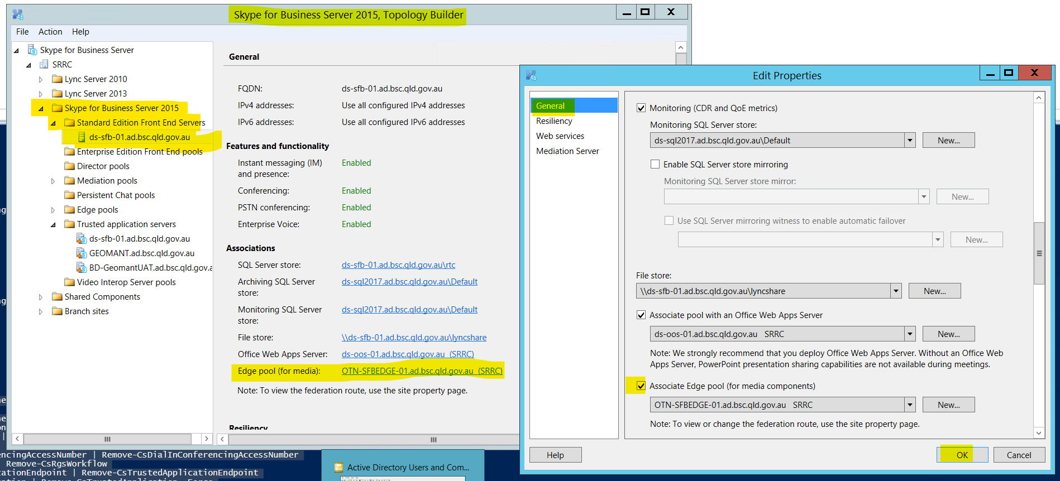

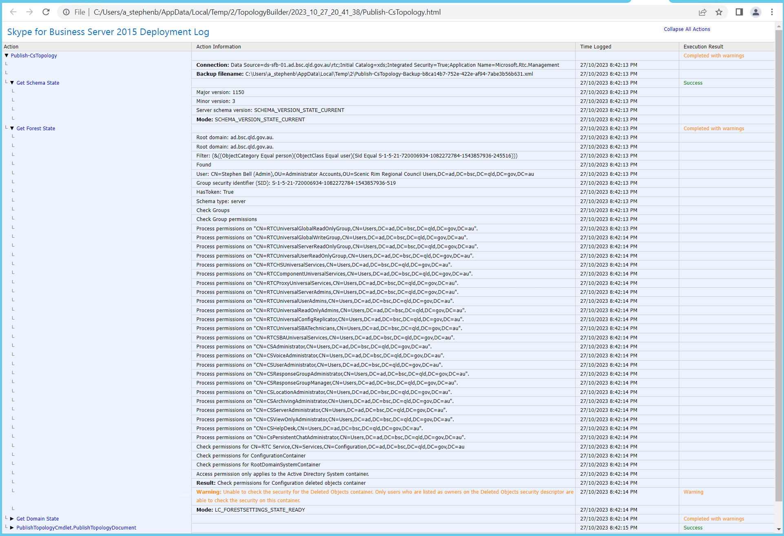

PS C:\Users\a_stephenb> Get-CsUser | Select-Object SipAddress, UserPrincipalName

PS C:\Users\a_stephenb> Get-CsMeetingRoom | Disable-CsMeetingRoom

Get-CsCommonAreaPhone | Remove-CsCommonAreaPhone

Get-CsAnalogDevice | Remove-CsAnalogDevice

Get-CsExUmContact | Remove-CsExUmContact

Get-CsDialInConferencingAccessNumber | Remove-CsDialInConferencingAccessNumber

Get-CsRgsWorkflow | Remove-CsRgsWorkflow

Get-CsTrustedApplicationEndpoint | Remove-CsTrustedApplicationEndpoint

Get-CsTrustedApplication | Remove-CsTrustedApplication -Force

Get-CsPersistentChatEndpoint | Remove-CsPersistentChatEndpoint

Get-CsCallParkOrbit | Remove-CsCallParkOrbit -Force

Get-CsVoiceRoute | Remove-CsVoiceRoute -Force

Get-CsUnassignedNumber | Remove-CsUnassignedNumber -Force

PS C:\Users\a_stephenb> Get-CsUser

PS C:\Users\a_stephenb> Get-CsOnlineUser -Filter {IsSipEnabled -eq $True} | Where {$_.UserValidationErrors -ne $null} | Select SipAddress,InterpretedUserType,UserValidationErrors

Get-CsOnlineUser : Session is not established, run Connect-MicrosoftTeams before requesting access token

At line:1 char:1

+ Get-CsOnlineUser -Filter {IsSipEnabled -eq $True} | Where {$_.UserVal ...

+ ~~~~~~~~~~~~~~~~~~~~~~~~~~~~~~~~~~~~~~~~~~~~~~~~~~~~~~~~~~~~~~~~~~~~~

+ CategoryInfo : NotSpecified: (:) [Get-CsOnlineUser], UnauthorizedAccessException

+ FullyQualifiedErrorId : System.UnauthorizedAccessException,Microsoft.Teams.ConfigApi.Cmdlets.GetCsOnlineUser

PS C:\Users\a_stephenb> Get-CsManagementStoreReplicationStatus

UpToDate : True

ReplicaFqdn : ds-sfb-01.ad.bsc.qld.gov.au

LastStatusReport : 27/10/2023 11:53:44 PM

LastUpdateCreation : 27/10/2023 11:53:41 PM

ProductVersion : 6.0.9319.0

PS C:\Users\a_stephenb> Get-CsManagementStoreReplicationStatus -CentralManagementStoreStatus

LastUpdatedOn : 27/10/2023 11:53:37 PM

ActiveMasterFqdn : DS-SFB-01.ad.bsc.qld.gov.au

ActiveMasterLastHeartBeat : 27/10/2023 11:57:41 PM

ActiveFileTransferAgentFqdn : DS-SFB-01.ad.bsc.qld.gov.au

ActiveFileTransferAgentLastHeartBeat : 27/10/2023 11:57:38 PM

ActiveReplicas : {ds-sfb-01.ad.bsc.qld.gov.au}

DeletedReplicas : {BEAU-SBA01.ad.bsc.qld.gov.au, BOON-SBA01.ad.bsc.qld.gov.au, OTN-SFBEDGE-01.ad.bsc.qld.gov.au}

PS C:\Users\a_stephenb> Get-CsUser -Filter { HostingProvider -eq "SRV:"} | Select-Object Identity, SipAddress, UserPrincipalName, RegistrarPool

PS C:\Users\a_stephenb> Get-CsUser | Select-Object SipAddress, UserPrincipalName, SamAccountName, RegistrarPool, HostingProvider, EnabledForFederation, EnabledForInternetAccess, LineUri, EnterpriseVoiceEnabled, HostedVoiceMail | Sort SipAddress

PS C:\Users\a_stephenb>

Restarted DS-SFB-01

Exported topology:



Interpreted User Type before:

PS C:\Users\a_stephenb> $csOnline | group AccountType,InterpretedUserType -NoElement | sort Name | ft -auto

Count Name

----- ----

30 ResourceAccount, PureOnlineApplicationInstance

1 SfbOnPremUser, DirSyncEnabledOnlineActiveDirectoryDisabledUser

6 SfbOnPremUser, HybridOnPremActiveDirectoryDisabledUser

1 SfbOnPremUser, HybridOnPremMisconfiguredTeamsOnlyUser

3 Unknown, DirSyncDisabledOnlineTeamsOnlyUser

11 Unknown, DirSyncDisabledOnlineTeamsOnlyUserWithNoService

1 Unknown, DirSyncEnabledOnlineActiveDirectoryDisabledUser

2 User, DirSyncEnabledOnlineActiveDirectoryDisabledUser

82 User, DirSyncEnabledOnlineTeamsOnlyUser

5 User, HybridOnlineActiveDirectoryDisabledUser

387 User, HybridOnlineTeamsOnlyUser

8 User, PureOnlineTeamsOnlyUser

#Export current ADUSer state to .csv

Get-ADuser -Properties msRTCSIP-DeploymentLocator,msRTCSIP-PrimaryHomeServer,msRTCSIP-UserEnabled -Filter {msRTCSIP-DeploymentLocator -like "*"} | Select UserPrincipalName,msRTCSIP-DeploymentLocator,msRTCSIP-PrimaryHomeServer,msRTCSIP-UserEnabled | Export-CSV C:\temp\SRRC-msRTCSIP-DeploymentLocator-Before.csv

#Clear attributes to change interpreted user type to not be hybrid

Get-ADuser -Properties SAMAccountName,msRTCSIP-DeploymentLocator,msRTCSIP-PrimaryHomeServer,msRTCSIP-UserEnabled -Filter {msRTCSIP-DeploymentLocator -like "*"} | Set-ADUser -Clear msRTCSIP-DeploymentLocator -Verbose

#Export current ADUSer post change state to .csv

Get-ADuser -Properties msRTCSIP-DeploymentLocator,msRTCSIP-PrimaryHomeServer,msRTCSIP-UserEnabled -Filter {msRTCSIP-DeploymentLocator -like "*"} | Select UserPrincipalName,msRTCSIP-DeploymentLocator,msRTCSIP-PrimaryHomeServer,msRTCSIP-UserEnabled | Export-CSV C:\temp\SRRC-msRTCSIP-DeploymentLocator-After.csv

#Check number and count of different InterpretedUSerTypes - Can take around 20-30 mins after an AD sync

$csonline = Get-CsOnlineUser -ResultSize ([int]::MaxValue)

$csOnline | group AccountType,InterpretedUserType -NoElement | sort Name | ft -auto

After:

